<https://houxianxu.github.io/images/logisticRegression/4.png>

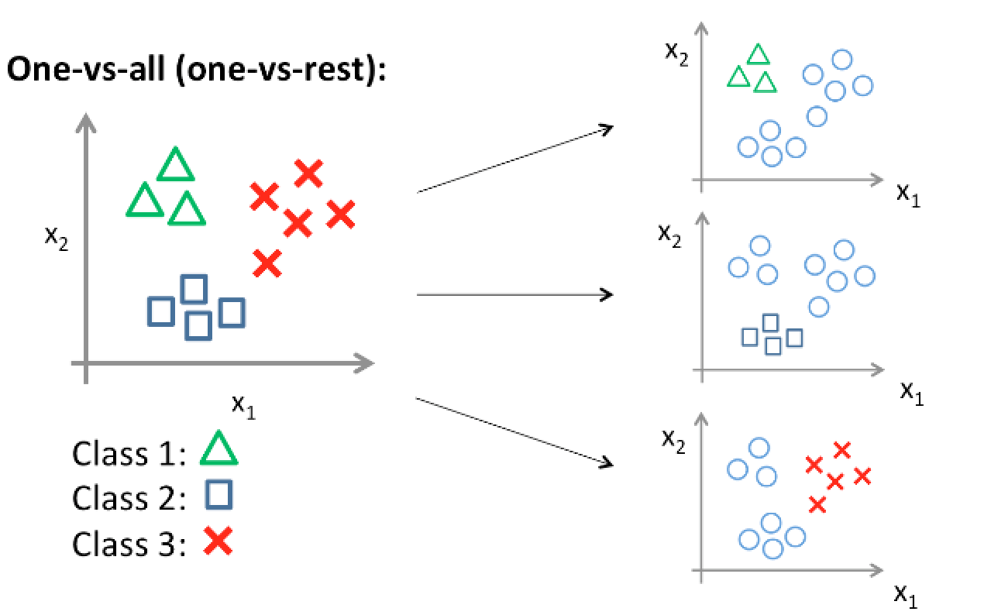

[https://cdn-images-1.medium.com/max/1200/0*0o8xIA4k3gXUDCFU.png](https://cdn-images-1.medium.com/max/1200/0*0o8xIA4k3gXUDCFU.png)

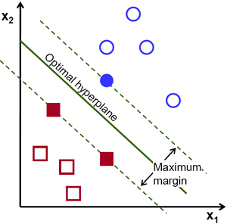

<https://blog-c7ff.kxcdn.com/blog/wp-content/uploads/2017/02/kernel.png>

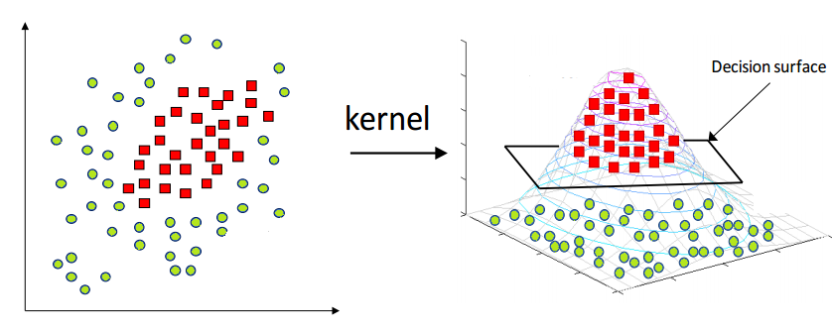

<https://www.researchgate.net/profile/Jan_Hasenauer/publication/225085262/figure/fig3/AS:213425717288963@1427896064381/Support-vector-machine-for-subgroup-classification-Visualization-of-the-SV-machine.png>

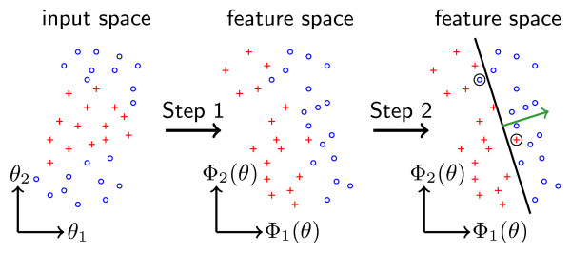

<https://image.slidesharecdn.com/20170405berlinbdbmeetup-introtoai-170410103218/95/introduction-to-artificial-intelligence-ai-bigchaindb-ipdb-meetup-4-april-05-2017-4-638.jpg?cb=1492588966>

